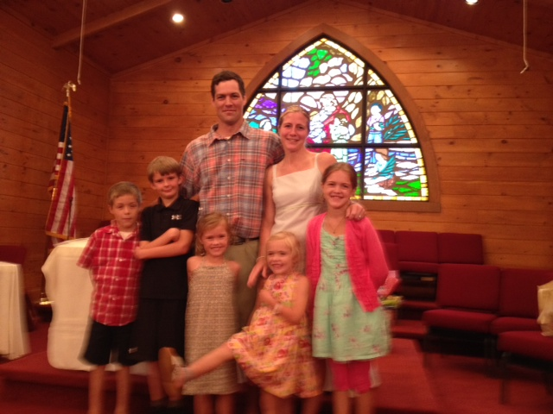

Coach Davis
I grew up in Middletown, RI. I graduated college from Baptist Bible College in Clarks Summit, PA with a degree in Health and Physical Education (K-12). I taught Health/PE at Leesville Elementary School for 6 years and Leesville Middle School for 4.
I have lived in Rolesville for the past 10 years.
I currently am in charge of Gradpoint at Rolesville High School.
I have coached many sports including middle school track, football, softball, and basketball. Also, high school girls golf, wrestling, and presently volleyball at Rolesville.
I have been married for 12 years and my wife and I have 5 kids; Harper (10), Lane (9), Silas (8), AJ (6), and Ollie (4). My oldest four kids attend Rolesville Elementary.
I am currently the staff advisor for Rolesville HS FCA club.
